**Stacker Game Template**

Modulette ID:

Game #

Game Title: Stacker

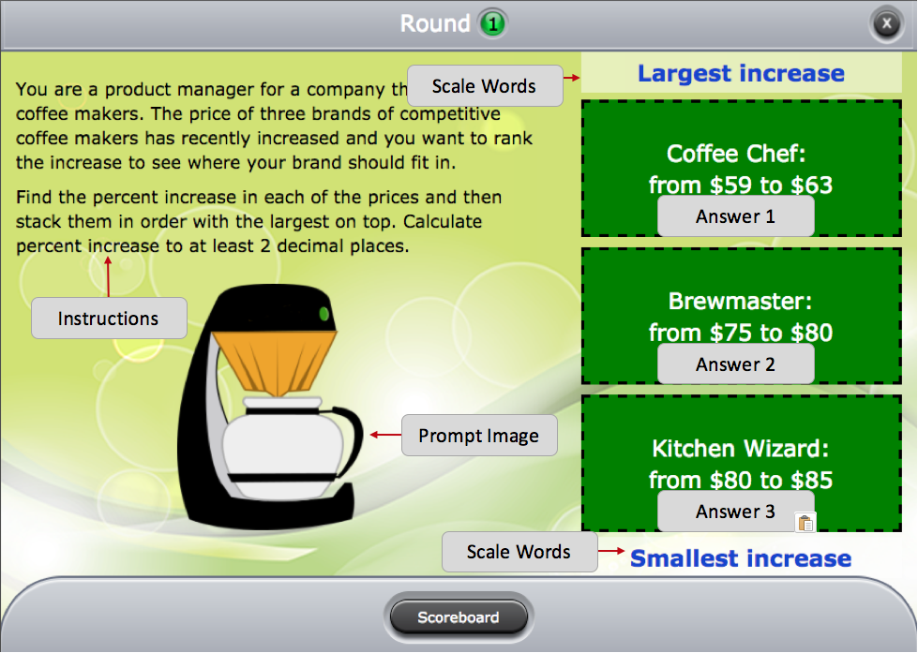

**Instructions:** [Use if the instructions are the same for the entire game]

Round #

**Instructions:** (Presents the scenario and give instructions for how answers should be stacked)

**Prompt Image:** (Context image for the round)

**Scale words:** (Labels for either end of the stacker pile)

**Correct feedback:** (Feedback that will display when the answers are stacked in the correct order)

**General incorrect feedback:** (Feedback that will display for incorrect stack)

**Answers** (List answers in correct stack order):

|  |
| --- |
| Answer 1 |
| Answer 2 |
| Answer 3 |

**Specific incorrect feedback table:**

|  |  |
| --- | --- |
| Put each answer on a separate line and in the order that will trigger the feedback.  For example:  (Answer 3)  (Answer 2)  (Answer 1) | (Feedback that will display when answer are stacked in this particular order) |